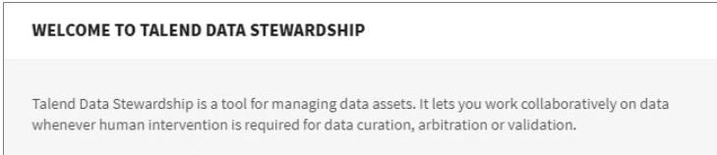

RESOLUTION CAMPAIGN:

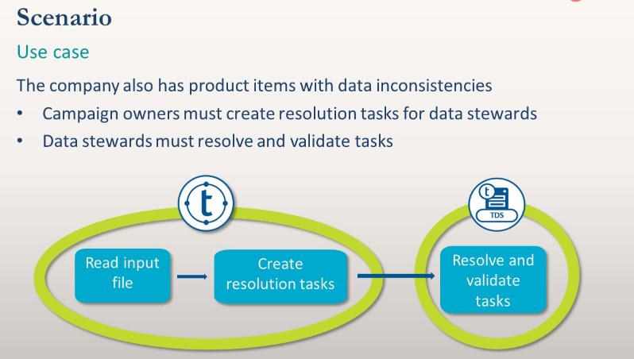

GROUPING CAMPAIGN:

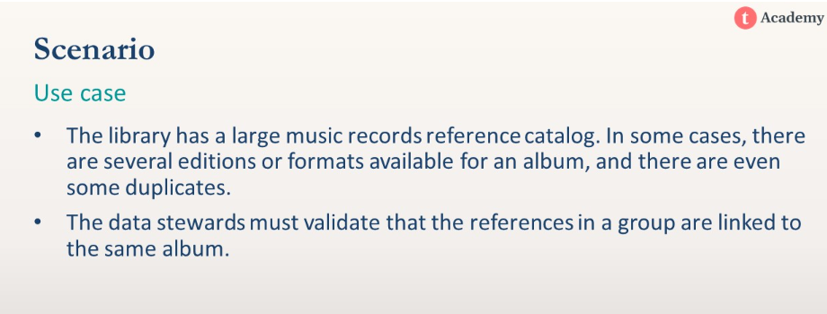

* A grouping campaign has some similarities to an arbitration campaign, because the data steward must answer a question to resolve tasks. However, the purpose is to legitimate the content of a group.

ARBITRATION CAMPAIGN:

* An Arbitration campaign defines a list of possible arbitration choices for the campaign tasks. The outcome of an arbitration task is the arbitration choice made by data stewards.
* Campaign owners can create the campaign to determine the structure of the data to be managed, the actions to be taken on data, and which data stewards to work on what tasks.

MERGING CAMPAIGN:

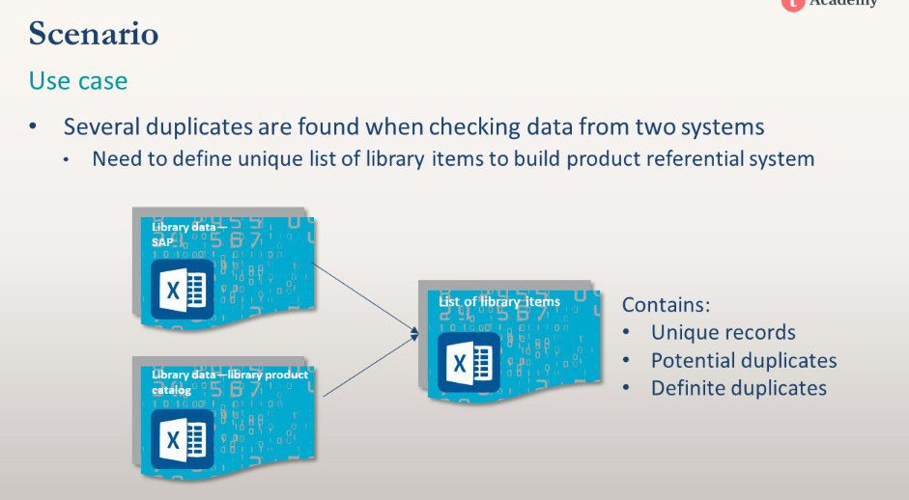

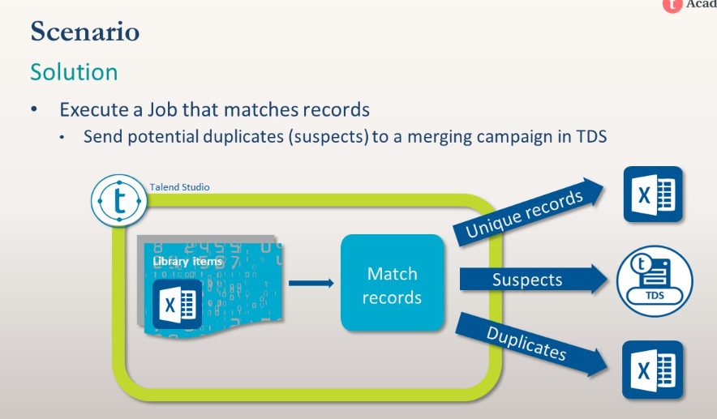

* A merging campaign enables you to choose fields for determining a match between records and then merge the records. Once data is deduplicated, the unique list of product items can be uploaded to any product referential system

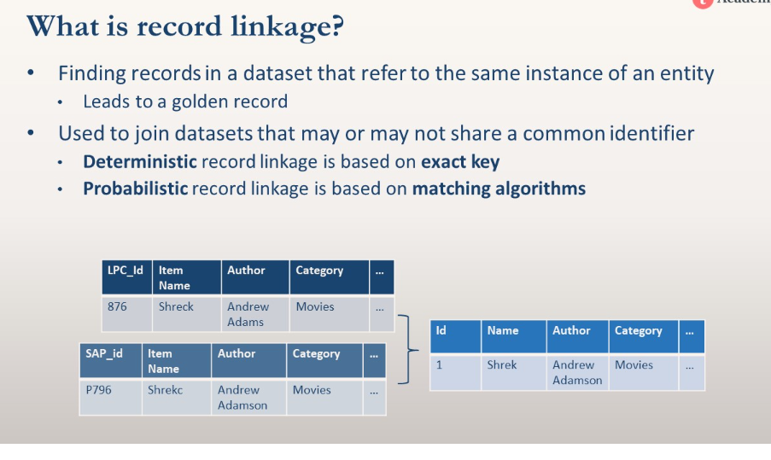

* **Jaro-Winkler**: same as Jaro, but with more importance given to beginning of word. Best suited for short strings such as names of people
* **Q-grams**: slides a window of length q over the string and compares number of matching q-grams with the total number of q-grams
* EX: Trigrams (q=3) is currently implemented

For example: « match » → « **m », « *ma », « mat », « atc », « tch », « ch* », « h** »

